1. **Introduction to drilling machine.**
2. **Perform straight drilling to calculate Material removal rate and Machining Time.**

**Apparatus:**

Drill machine, vernier caliper, Aluminum slab.

**Apparatus:**

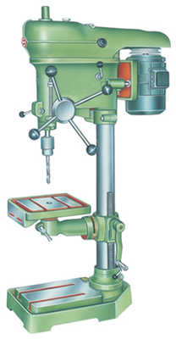

**Theory**

 The drilling machine or drill press is one of the most common and useful machine employed in industry for producing forming and finishing holes in a workpiece. The unit essentially consists of:

1. A spindle which turns the tool (called drill) which can be advanced in the workpiece either automatically or by hand.

2. A work table which holds the workpiece rigidly in position

**Working principle**

The rotating edge of the drill exerts a large force on the workpiece and the hole is generated. The removal of metal in a drilling operation is by shearing and extrusion.

**Construction**

The machine has only a hand feed mechanism for feeding the tool into the workpiece. This enables the operator to feel how the drill is cutting and accordingly he can control the down feed pressure. Sensitive drill presses are manufactured in bench or floor models, i.e., the base of machine may be mounted on a bench or floor.

The main operating parts of a sensitive machine/drill press are Base, Column, Table, and Drill Head.

**1. Base:** The base is a heavy casting that supports the machine structure; it provides rigid mounting for the column and stability for the machine. The base is usually provided with holes and slots which help to Bolt the base to a table or bench and allow the work-holding device or the workpiece to be fastened to the base.

**2. Column**: The column is a vertical post that Column holds the worktable and the head containing the driving mechanism. The column may be of round or box section.

**3. Table:** The table, either rectangular or round. Drill machine/press in shape supports the workpiece and is carried by the vertical column. The surface of the table is 90-degree to the column and it can be raised, lowered and swiveled around it. The table can be clamp/hold the required the workpiece. Slots are provided in most tables to allow the jigs, fixtures or large workpieces to be securely fixed directly to the table.

**4. Drilling Head:** The drilling head, mounted close to the top of the column, houses the driving arrangement and variable speed pulleys. These units transmit rotary motion at different speeds to the drill spindle. The hand feed lever is used to control the vertical movement of the spindle sleeve and the cutting tool

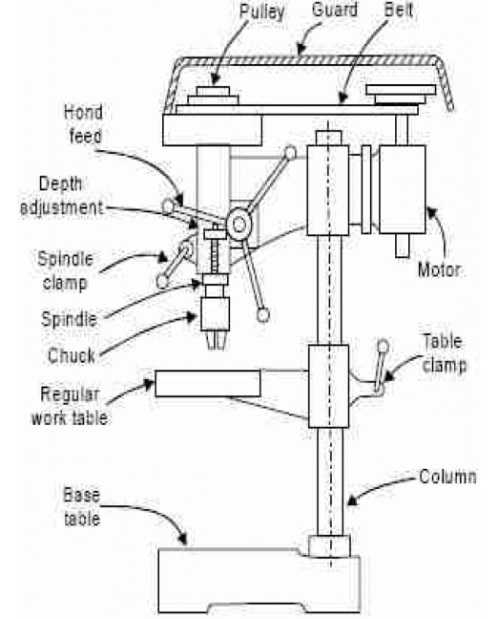

**Parts Of Drill Bit**

Drill bit is made from a round bar of tool material, and has three principles parts: the point, the body and the shank. The drill is held and rotated by its shank. The point comprises the cutting elements while the body guides the drill in the operation. The body of the drill has two helical grooves called “flutes”. The flutes from the cutting surface and also assist in removing chips out of the drilled hole. The parts of twist drill are

**1: point:**

The point is the cone shaped end and it does the cutting. It consists of the following:

**(A) dead center:** It is the sharp edge at the extreme tip of the drill. This should always be the exact center of the drill.

**(B) Lips:** these are the cutting edges of the drill.

**(C) Heel :** It is the portion of the point back from the cutting edge.

**2: Shank :**

It is the portion of the drill by which it is clamped in the spindle. The shank may be either straight or tapered. Straight shank drills are used with a chuck. Tapered shank drills have self-holding tapes that fit directly into the drill press spindle. On the taper shank is the another term is used which is called tang. This fits into a slot in the spindles sleeve.

**3: Body:**

It is the portion between the point and the shank. The body consists of the following parts:

**(A) Flutes :**

Two or more spiral grooves that run the length of the drill body are called flutes. The flutes do four thing.

* Help from the cutting edge of the drill point.
* Curl the chip tightly for easier removal.
* From channels through which chips can escape from the hole being drilled.
* Allow the coolant and lubricant to get down to the cutting edge.

**(B) Margin**

It is the narrow strip extending back the entire length of the flute. It is the full diameter of the drill.

**(C) Body Clearance:**

It is the part of the drill body that has been reduced in order to cut down friction between the drill and the wall of the hole.

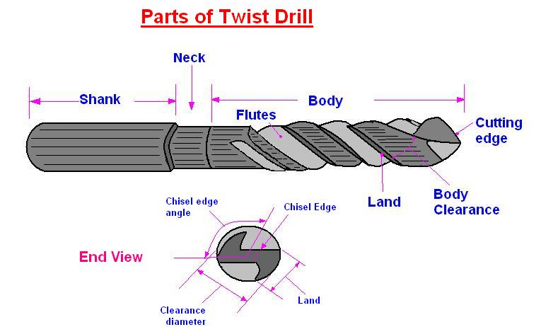

**CUTTING CONDITIONS IN DRILLING**

**Cutting Speed**

The cutting speed in a drilling operation is the surface speed at the outside diameter of the drill. It is specified in this way for convenience, even though nearly all of the cutting is actually performed at lower speeds closer to the axis of rotation. To set the desired cutting speed in drilling, it is necessary to determine the rotational speed of the drill. Letting N



where v = cutting speed, mm/min (in/min); and D = the drill diameter, mm (in). In some drilling operations, the workpiece is rotated about a stationary tool, but the same formula applies

**Feed**

Feed f in drilling is specified in mm/rev (in/rev). Recommended feeds are roughly

proportional to drill diameter; higher feeds are used with larger diameter drills. Since there are (usually) two cutting edges at the drill point, the uncut chip thickness (chip load) taken by each cutting edge is half the feed. Feed can be converted to feed rate using the same equation as for turning



where fr = feed rate, mm/min (in/min). Drilled holes are either through holes or blind holes, Figure. In through holes, the drill exits the opposite side of the work; in blind holes, it does not.

**Machining Time**

The machining time required to drill a through hole can be determined by the following formula



where Tm = machining (drilling) time, min; t = work thickness, mm (in); fr = feed rate, mm/min (in/min); and A = an approach allowance that accounts for the drill point angle, representing the distance the drill must feed into the work before reaching full diameter,

This allowance is given by



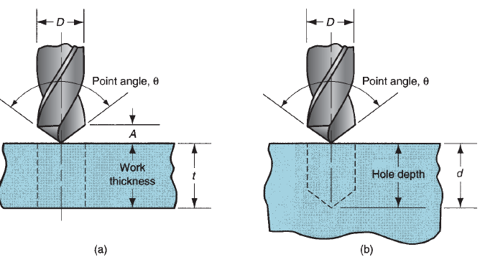

Fig:(a)Through hole (b) blind hole

**Procedure**

* Calculate feed rate of drill machine ,give a complete rotation to spindle handle and measure distance travel by tool and its time
* Adjust workpiece in vise
* Move spindle handle to create hole and measure machining time

**Observations & Calculations**

Approach Distance=

|  |  |  |  |  |  |  |  |
| --- | --- | --- | --- | --- | --- | --- | --- |
| Sr.No | Depth of Hole  (L) | Diameter of Drill Bit  (D) | RPMS | Feed rate  Fr | MRR  = $\frac{πD^{2}Fr}{4}$ | Machining Time=TM  = | Actual Machining Time=Ta |
|  | mm | mm |  | mm\mint | mm\mint | mint | mint |
| **1.** |  |  |  |  |  |  |  |
| **2.** |  |  |  |  |  |  |  |
| **3.** |  |  |  |  |  |  |  |

**Questions**

What is difference between turret and Gang type Drill Machine?

_________________________________________________________________________________________________________________________________________________________________________________________________________________________________

Define rake and helix angle in drill bit?

_________________________________________________________________________________________________________________________________________________________________________________________________________________________________

Write different types of drill bits?

_________________________________________________________________________________________________________________________________________________________________________________________________________________________________

Write about the operations related to drilling?

______________________________________________________________________________________________________________________________________________________

**Comments on**

Factors effecting machining time in drill machine?

**______________________________________________________________________________________________________________________________________________________**